Lab 2

Write a JAM plan to move the agent in a square spiral search pattern.  
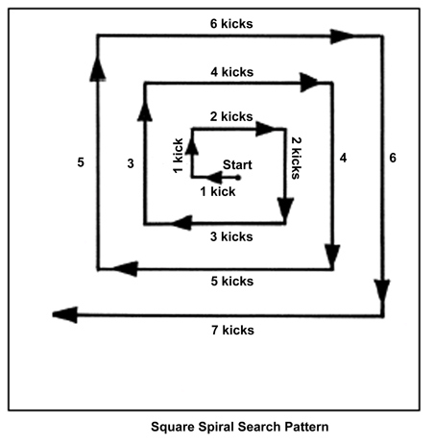

Hints

In terms of design you can write the following plans:

* Move one step
* Move a section (which might include a parameter for number of steps)
* Top-level plan to make turns and decide how many steps a section needs

Keep the position in the world-model using a fact. Define an end position fact that is at the end of a section.

Intermediate

Define an end position fact that may be at any position, not just ends of sections. Succeed the main plan when the agent is over that position.